Submit Your Paper as a Word and PDF File without page numbers or headers by June 24, 2021. Title Font: Times New Roman 14 point

First Author1, Second Author1,2, and Third Author2

1University of Somewhere, Utopi, Alfheim

2Institute of Something, Arcadia, Svartálfaheimr

ABSTRACT

Authors are requested to follow the instructions described in this guide to ensure a uniform printing style in the proceedings. This document is written following the guidelines so you can use it as a template when writing your contribution. For submission dates, please see the conference website. The manuscript of **both oral presentations and posters** must be submitted both as **a DOC file and a PDF file**. Make sure that you use “press quality”, embed all the fonts, and set the paper size to A4 when you convert the document to PDF. If the guidelines are not followed exactly, your paper will be returned to you for correction. A LaTeX template is available by request from the ATNRS Editor [a.h.rabenja@uis.no](mailto:a.h.rabenja@uis.no).

INTRODUCTION

The current volume of the Annual Transactions will be posted on the NRS website after the conference, with each paper or poster summary in an individual PDF file. Your submission of a paper or a poster summary implies that you agree to publication in both print and PDF format.

Manuscripts should be written in English and **must be minimum 2 pages and maximum 8 pages long**. All manuscripts should start with a short abstract of maximum 100 words. The Abstract should be followed by an Introduction section. Authors may use other sections with appropriate headings in the body of the manuscript. References must be the last section.

FONT AND STYLE

Use **12 point Times New Roman** font in the body of the manuscript, 14 point for the title of the paper, and 10 point for superscripts and subscripts. Do not use bold type face. Make sure to choose a readable font size for your figures (8-10 point).

MARGINS

Use A4 paper (21 by 29.7 cm). Leave a blank space of 40 mm of at the top of the first page, 26 mm at the top of subsequent pages. The bottom margin is set to 36 mm on all pages. The left and right margins are 26 mm and 24 mm respectively.

Text should be written in two columns each 76 mm wide and separated by a width of 8 mm. Text should be single spaced and right justified. Do not number the pages.

The first page begins with the title, author names and addresses (40 mm from the top of the page). Add one blank line between the title and the line with the author names.

On the second line below the author names, present the affiliation and addresses of the authors. Add three blank lines between addresses and affiliation and the main text. If the authors have different addresses use number superscripts to refer to their addresses, as indicated above. Centre the section containing the title, author names and addresses.

HEADINGS AND PARAGRAPHS

Use capital letters to clearly identify your main section headings.

Make sure there is one blank line before each main section heading and before each subheading, but not between paragraphs.

Subheadings

Subheadings within a main section should be written with normal letters but should be underlined, with a blank line before the heading.

Paragraphs should be indented 6 mm from the left margin. There is no blank line between paragraphs.

EQUATIONS

Equations should be adjusted to the left, and numbered consecutively with the equation number in parenthesis at the right hand side of the column. Equations should be abbreviated by Eq. and number in the text. For example see Eq. 1.

c= (1)

Use a blank line before and after each equation. Define all non-trivial symbols used in equations and in the text. Use SI-units whenever possible.

MAKING REFERENCES

References in the text should be numbered consecutively with superscripts. For example, gelation was observed in an earlier study1 using a different technique but Jensen and Hansen1 stated there was no gelation. If there are more than two authors use the format Barnes et al.2 presented a review on suspension rheology.

Update 2019: in order to facilitate the writing process, the bibliography style has been changed to the Chicago (sixteenth edition) style included in MS Word.

FIGURES AND TABLES

Number figures and tables consecutively and refer to each figure and table in the text.

Figures and tables can be positioned anywhere in the text columns. If a figure or table requires more than a column width, then position it at the top or bottom of a page. Please note that the transactions will be printed in black & white, so do not use colour-identification in the figures.

Photographs may be included if they are legible when printed.

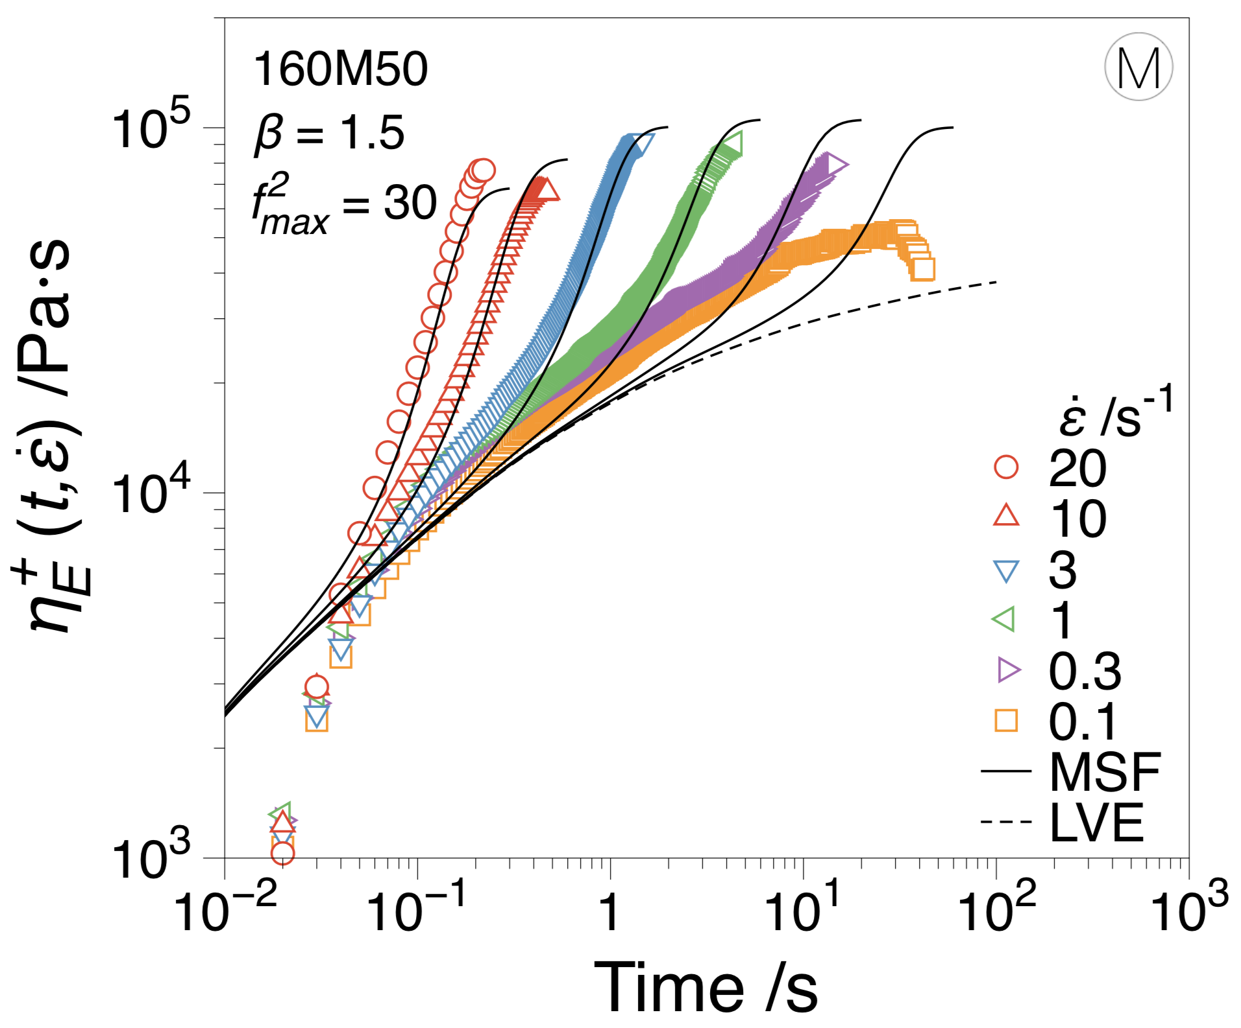

Figure 1. Center your figures and figure captions and ensure that the font size in the figures is legible.

Refer to figures as Fig. 1 and tables as Table 1 in the text. The word “Figure” or “Table” should be written out in full in a caption. Captions should be placed below figures (see Fig. 1) but above tables (see Table 1). Remember to use capital F in “Fig.” and “T” in Table. Explain the legends in your figures. Allow sufficient space above and below figures, tables, and their captions to separate them clearly from the main text.

Table 1. Tables and table captions should be centred.

|  |  |
| --- | --- |
| X | 1 |
| Y | 2 |

ACKNOWLEDGMENTS

Thank you for following these guidelines. We look forward to welcome you to the conference!

REFERENCES

The bibliography style has been changed to the Chicago (sixteenth edition) style included in MS Word.