I am submitting this abstract to the  Nordic Rheology Conference

Nordic Polymer Days

I wish to present this contribution as  an oral presentation

a poster presentation

**The abstract should be written on page 2 of this document following the provided instructions.**

**Abstract Title**

**First author1, Presenting author2, Third author2\***

**1 University of Norden, Scandinavia**

**2 Nordic University, Fennoscandia**

* Email address of the corresponding author

The abstract title is center-aligned and in bold, typed in Times New Roman with 16 pt font size. The authors and affiliations are center-aligned and in italics, typed in Times New Roman with 11 pt font size. The email address of the corresponding author is center-aligned and typed in Times New Roman with 11 pt font size. The body text is justified and typed in Times New Roman with 11 pt font size. Paragraphs are separated by a blank line. The abstract must not exceed one page (including figures and references). Submit your manuscript as a .doc or .docx file to [abstract-submission@nrc-npd2021.fi](mailto:abstract-submission@nrc-npd2021.fi) by May 14, 2021.

Lorem ipsum dolor sit amet, consectetuer adipiscing elit. Sed posuere interdum sem. Quisque ligula eros ullamcorper quis, lacinia quis facilisis sed sapien. Mauris varius diam vitae arcu. Sed arcu lectus auctor vitae, consectetuer et venenatis eget velit. Sed augue orci, lacinia eu tincidunt et eleifend nec lacus. Donec ultricies nisl ut felis, suspendisse potenti. Lorem ipsum ligula ut hendrerit mollis, ipsum erat vehicula risus, eu suscipit sem libero nec erat. Aliquam erat volutpat. Sed congue augue vitae neque. Nulla consectetuer porttitor pede. Fusce purus morbi tortor magna condimentum vel, placerat id blandit sit amet tortor.

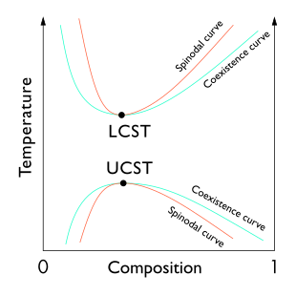

**Figure 1.** Lorem ipsum dolor sit amet, consectetuer adipiscing elit

References

1. Author, A.; Author, B. *Journal abbreviaton* **Year**, *Volume*, pages*.*
2. Canham, L. *Nature* **2000**, *408*, 411-412*.*
3. Paterson, S.; Brown, H.; Chirila, T.; Keen, I.; Whittaker, A.; Baker, M. *J. Polym. Sci., Part A: Polym. Chem.* **2010**, *48*, 4084–4092.